  **Mobile testing**

**App version v3.0.8**

**Xiaomi A1: Android 9**

**Reporter Haykanush Grigoryan**

**Checklist**

1. Check that the application download process is running normally
2. Check that the application works as per as requirement whenever the application starts/stops
3. Check the app's performance when you receive a call or message
4. Check that the application allows necessary social network options such as sharing, posting and navigation etc.
5. Check that the page scrolling scenarios are being enabled in the application as necessary that the user
6. Check receives an appropriate error message like “Network error. Please try after some time” whenever there is any network error
7. Check application’s behavior in cases of internet manipulations: 2G, 3G and 4G.
8. Check the response time of the application is as per as the requirements.
9. Check that there is pre-defined search criteria for auto complete e.g. after typing first 3 letter it should suggest matching keyword
10. Check application should not crash when user insert "?" or any symbol in search field
11. Check that the location of the branched for any organization has the right point is the map which shows exactly the place of the branch building/address.
12. Check that everything in the app is translated when the language of the app is changed.
13. Check that both the working hours and the break hours of the banks and other organizations are mentioned in the app
14. Check that the emails mentioned in the app are enabled (when you press on the email it goes to your mail to compose a letter)
15. Check that it is possible to create tickets for all the banks and organizations in the app.

**1.Bug report**

**Summary:** App crush/The back arrow navigation bug/  
**Description:**  
When you try to change the location and choose country different from Armenia, after choosing specific city or region of the chosen country, the back arrow navigation doesn't work properly and when you press it the app crashes ang goes back to the phones menu screen.  
**Steps to reproduce:**  
S1 Open Settings  
S2 Go to Change Location  
S3 Choose one of the countries /different from Armenia/  
S4 Choose one of the cities of that country  
S5 Press the back arrow

**Expected result:** The back arrow should work properly  
**Actual result:** app crash  
**Severity** high  
**Priority -**  
**Additional information**  App version v3.0.8  
Xiaomi A1: Android 9

**2.Bug report**

**Summery:** Two coupons at the same time  
**Description:** The program allows you to create a coupon at the same time of day

**Steps to reproduce:** for example  
created coupon on 01.03.2020 14:25 visit to Evocabank bank  
and second coupon the same time to the Cadastre comite  
**Expected result** the Application must not allowed this action  
**Actual result** : the Application allowed this action  
It would be more convenient if the app warns the user  
**Severity** -minor  
**Priority-**

**Additional information**  App version v3.0.8  
Xiaomi A1: Android 9

screenshot

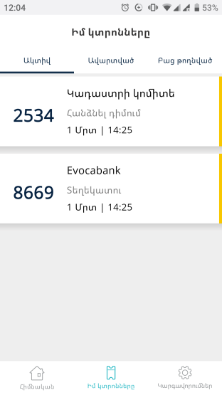

**3.Bug report**

**Summary:** there is a maps problem(and email ,number phone absent too)  
**Description**: selected branch hasn't map  
**Steps to reproduce:**   
S1 go to change location  
S2go to “North Macedonia “  
S3 click on select all button  
S4 Click on “Infosoft system doo” button  
S5 click on maps point button  
**Expected result:** we must see where is pointed “Infosoft system doo “branch  
**Actual result:**Map is opened but empty  
**Severity** high  
**Priority**   
**Additional information** App version v3.0.8  
Xaomi A1: Android 9

Screenshot

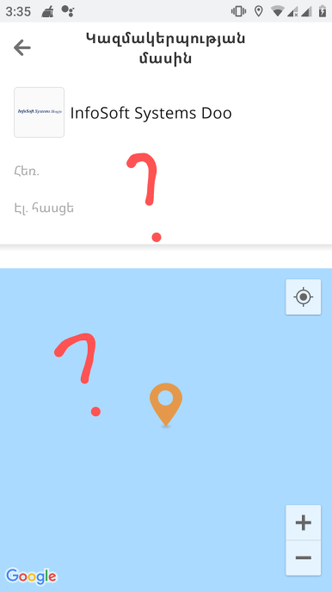

**4.Bug report**

**Summary**: The application is facing problem when the language is being changed from one to another.

**Description**: There is a problem changing the language in the settings section  
Steps to reproduce:  
S1 Go to settings page and tap on "Change the language button".  
S2Choose the language to be Russian  
S3 click on ‘’terms and condition button’’  
**Expected result:** The content must be written in Russian  
**Actual result**: The content is written in English  
**Severity** minor  
Priority -  
**Additional information** App version v3.0.8  
Xiaomi A1: Android 9

**5..Bug report**

**Summary**: Copy tool doesn't active  
**Description:** if the user wants to copy any email will not be able to  
**Steps to reproduce**:  
S1 click on Armenia button  
S2 click on Abovyan area  
S3 click Evocabank and information button.  
**Expected**: the user should be able to copy email  
**Actual result**: copy tool doesn't active  
**Severity** Major  
Priority   
**Additional information** : App version v3.0.8  
Xiaomi A1: Android 9